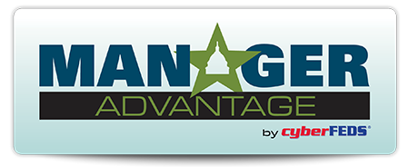

Dear <Insert your Supervisor’s Name>,

I would like approval to purchase a <one-year> subscription to **Manager Advantage by** ***cyber*FEDS®** from **LRP Media Group** for the purposes of equipping our agency’s managers and supervisors with professional development, training, and up-to-date guidance so they can help our agency avoid errors that may lead to costly litigation. Manager Advantage by *cyber*FEDS is the go-to online resource for guidance on workplace challenges that federal managers and supervisors at hundreds of agencies across the country already rely on.

This resource supports federal managers and supervisors through addressing more than 100 workplace topics; offers monthly free Lunch & Learn sessions; and includes scenario-based training videos, FAQs, dos and don’ts, and weekly e-updates that provide leadership skill development and late-breaking news. We are also able to completely manage and customize all the content as we see fit to match our agency's policies and preferences.

I am seeking approval for the subscription cost, which includes access to the Manager Advantage by *cyber*FEDS website for <insert total # of users> subscribers of our choice:

Subscription cost total: $<insert cost>

You can review information on **Manager Advantage** at [www.ManagerAdvantage.com](http://www.ManagerAdvantage.com). Please consider my request as this would be an invaluable learning resource for our agency’s managers and supervisors.

Sincerely,

<Insert your name>